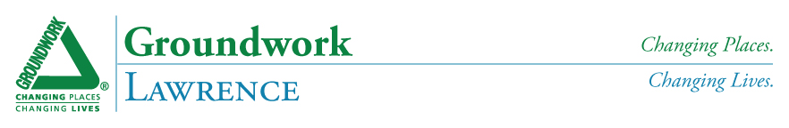

**Call for Eco-Art celebrating GWL’s 11th Year**

**For Groundwork Lawrence’s Annual Glow Gala and Fundraiser**

**November 29, 2012, 6:00 – 10:00 PM**

**What is eco-art?**

* It incorporates at least one of the “4 R’s” (Reduce, Reuse, Recycle, Repair).
* It promotes environmental awareness.
* It educates others about environmental injustice and/or conveys a vision for addressing it.
* It is comprised of environmentally-friendly materials.

**Eco-art can include**: lanterns, home furnishings and housewares, photography, sculpture, paintings, or mixed media pieces. *However, it* ***must incorporate*** *at least 1 of the “4 R’s”* ***and*** *at least 1 other item listed above.*

**Submission Deadline:** Thursday, November 8, 2012, 5:00 PM (no exceptions)

**Pick-up/drop off location:** Groundwork Lawrence, 60 Island Street, Lawrence, MA

**Artwork will be juried:** Nov. 14 – 15; items not selected for the show should be picked up Nov. 19-20

**Auction proceeds are split 50/50** between Groundwork Lawrence and the artist; each artist receives 2 tickets to Glow

**All submissions must be accompanied by the Eco-Art Registration Form and include a write-up** (see form).

**A minimum sale price for your submission may be set.**

**Items submitted in the past include**: artwork made from shredded catalogues, lamps made from “rescued roadside treasures,” paintings on used/discarded furniture, and lanterns made from reclaimed wood. For examples of previous eco-art, please visit [www.groundworklawrence.org](http://www.groundworklawrence.org) and follow the Flickr link on our home page. We encourage you to use your imagination to help promote Groundwork Lawrence’s environmental mission!

**How much should I expect my piece to sell for?** Items have sold for between $20 and $350. We have included items with a sale price up to $5,000. We encourage pieces with minimum sale prices of $20 - $300.

Groundwork Lawrence (GWL) has been making change happen in Lawrence, MA for 11 years. Through our environmental and open space improvements, community food programs, youth education and employment initiatives, and community programming and events, we create the building blocks of a healthy community and empower Lawrence residents to improve their quality of life. GWL achieves results by engaging the whole community – residents, youth, nonprofits, government and businesses – in the planning and realization of projects. This collaborative approach ensures that all stakeholders are mutually invested in GWL’s outcomes, a key to stable neighborhoods and sustainable change.

**Our projects and programs are designed to:**

* **Increase Opportunities for Physical Activity** through the development of parks, trails and recreational facilities that are safe, welcoming and accessible to all;
* **Increase Access to Healthy Food** by creating a citywide network of community and schoolyard gardens, managing the Lawrence Farmer’s Market and a community-supported agriculture (CSA) program;
* **Improve the Quality of Our Air, Water and Land** through brownfield redevelopment, volunteer cleanups, tree planting, and integration of low-impact development techniques;
* **Support Biodiversity** by implementing habitat enhancement and restoration projects;
* **Reduce Energy Consumption** through the development of pedestrian-friendly neighborhoods and the use of locally-sourced and recycled materials for project construction.
* **Prepare young people** to be positive role models and future leaders in their community.