

LAWRENCE: Federal regulators review safety of Riverwalk
By Bill Kirk
Staff writer
—
LAWRENCE — Federal regulators yesterday visited the city to review the safety of Great Stone Dam and whether people walking along a proposed 1.3-mile pathway along the river's edge, or sitting on an outdoor deck at Salvatore's Restaurant, would be in harm's way in the unlikely event of a dam collapse.
Those who attended agreed that while the meeting was cordial and productive, the fate of the proposed Riverwalk and the 2,690-square-foot deck attached to the river side of 250 Merrimack St. rests with federal regulators.
"Confidence is high we'll resolve this in a positive way for everybody," said Julie Smith-Galvin, director of corporate affairs for Enel North America, which owns the dam as well as the land along the river's edge — including the property Sal's deck is on.
Smith-Galvin said last week that a review by the Federal Energy Regulatory Commission was prompted by Groundwork Lawrence, which received a state grant to do a feasibility study of the Riverwalk.
During that review, Enel North America learned that Sal's deck was on its property as was the proposed Riverwalk. Because Enel operates a hydroelectric plant on the south side of Great Stone Dam, FERC needed to be involved.
A dam breach study done for FERC by the engineering firm Gomez and Sullivan was conducted to show what would happen in the event of a dam collapse. That study was sent to Washington and yesterday officials from FERC visited the site.
They met with Salvatore Lupoli, owner of Salvatore's Restaurant at 250 Merrimack St., as well as Mayor Michael Sullivan, City Planner Michael Sweeney, Economic Development Director Tom Schiavone, Sen. Susan Tucker, D-Andover, two people from U.S. Rep. Niki Tsongas' office, as well as Katie O'Brien and Heather McMann of Groundwork Lawrence. The meeting was at the Enel offices in Andover.
Schiavone said FERC officials seemed "comfortable" with what was going on in Lawrence. "They've walked the riverbank and have looked at the dam breach study. They just need some additional information, but I don't anticipate anything drastic occurring."
In a story last week, Smith-Galvin of Enel said due to safety concerns, it was possible the deck would have to be removed so as not to place diners in danger in the event of a dam collapse.
Schiavone and others said that topic barely came up during yesterday's meeting.
"I left the meeting satisfied," he said. "Sal's deck is not of concern."
Lupoli, in an e-mailed statement to The Eagle-Tribune, agreed.
"The meeting with FERC and Enel was very productive this morning," he wrote. "All parties involved walked away feeling very good. The issue mainly revolves around the inspection by FERC of the dam and is not directly related to the deck at Salvatore's Restaurant. The deck is not an issue. We will work with all agencies and the local, state and federal government to provide access to any information we have in regards to our buildings and the surrounding property. We were made to feel that we were a very important piece of the revitalization of Lawrence and our participation in the Dam assessment was minor if any."
Smith-Galvin said that if FERC decides the deck is not a safety concern, Enel would enter into some kind of agreement with Lupoli so that he can keep it while Enel's interests also are served.
"It is our property, so as soon as we're comfortable there's no public safety concern, then it becomes a simple business-to-business concern," she said. "We'll enter into some sort of market-lease arrangement. Nothing unusual."
She said the discussion has been valuable because "in the future, now that it's clearly established that it's our land, we don't want people putting up structures without our OK. Going forward, we'll be involved much earlier" in similar-type projects.
Sweeney, the city planner, agreed, saying that "over the next three to five years, you're going to see a lot of development along the river. All of this will serve as a model on what can be done, how it should be done, and that we all need to be in touch on all these issues."
Sweeney said if FERC comes back and determines that Sal's deck is a safety concern, the 207-by-13-foot deck could be cantilevered out over the river using supports attached to the building rather than pilings planted on the ground below.
"That's been a possibility from the beginning," he said.
The Riverwalk would be a paved pathway about 12 feet wide along the south side of the river, from Sal's to Great Stone Dam.
Copyright © 1999-2006 cnhi, inc.
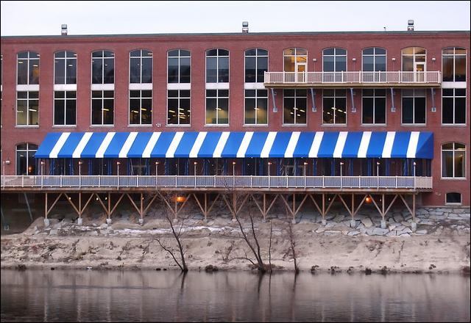
The deck overlooking the Merrimack River on Salvatore's Restaurant on Merrimack Street in Lawrence is on land belonging to the owners of the Great Stone Dam.
Carl Russo / Staff photo

